**Name: Waseem Hyder Qureshi**

**Network Engineer G Network 69 Wilson St, London, England, EC2A 2BB**



**GIT:**

Git is a distributed version control system that tracks changes in any set of computer files, usually used for coordinating work among programmers who are collaboratively developing source code during software development.

To install Git on a Linux machine, such as Ubuntu, you can use the following command:

**apt install git**

this commands will install Git on your Ubuntu system.

After installing Git, there will logically be three parts in Git: the working space where we write code, the staging area where we add code, and the local repository where we commit our code or files. This structure facilitates the process of version control and collaborative development.



To set up a username and email for the locally installed Git, you can use the following commands:

**git config --global user.name "WaseemHyder123"**

**git config --global user.email** [**waseem.hyder27@gmail.com**](mailto:waseem.hyder27@gmail.com)

**GIT Commit, PUSH and PULL:**

**Step 1:** Create a directory and place some files in it.



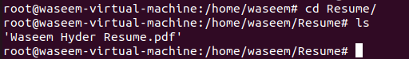

Then, you need to navigate inside the directory and initialize Git using this command:

**git init**

After initializing Git, you need to check the status of the repository.

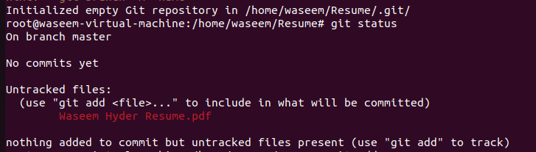

The file or code is currently located in the working space but has not been added yet. It appears as untracked. To include it in the staging area, you should use the git add . command.



Now that the file is in the staging area, we can proceed to commit it.

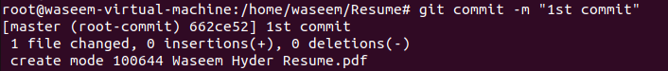

After committing, you can check the status again, and it should show that the file has been committed.



Now, the file has been successfully committed from the workspace to the local repository.

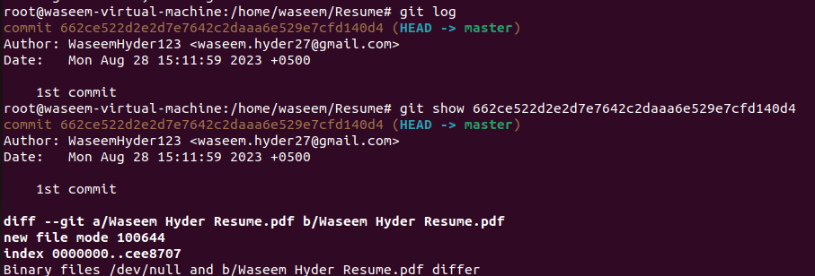

The output displays that the file has been committed along with its logs. To proceed, you should push the file from the local repository to the central repository.

Indeed, you can utilize various central repositories such as GitHub, GitLab, and others. These platforms offer remote storage for your code and facilitate collaborative development.

<https://github.com/>

Navigate to the GitHub central repository, create your account, and establish a new repository. This will enable you to start managing and sharing your code remotely.

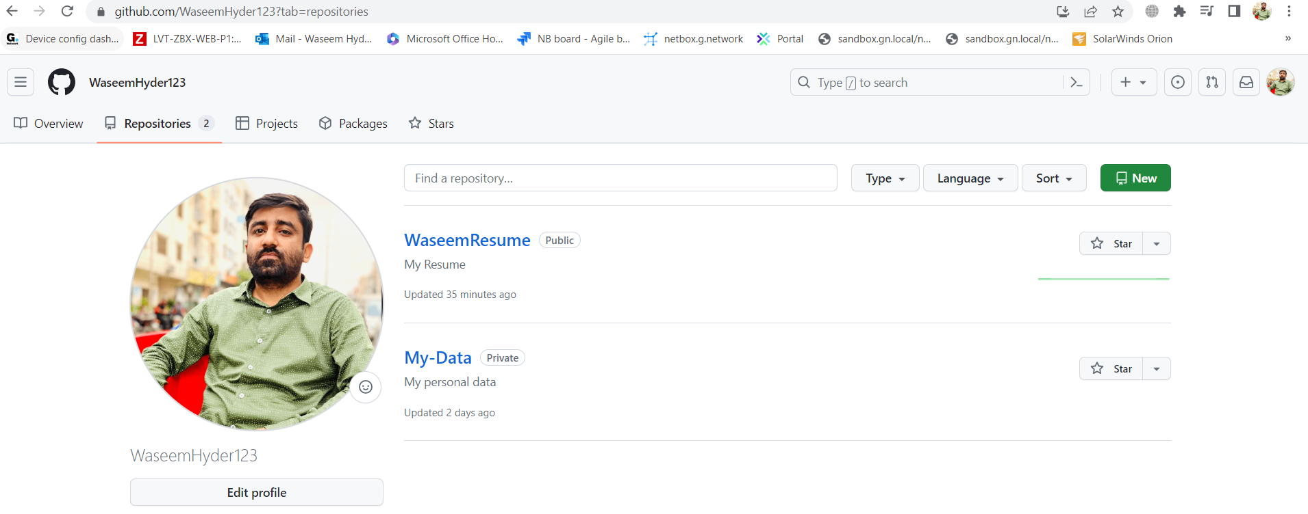

<https://github.com/WaseemHyder123/WaseemResume.git>

**PUSH:**

Now, you can push the file into the central repository by using the following commands:

Before pushing we need to add file or code into local repositry

**git remote add origin** [**https://github.com/WaseemHyder123/WaseemResume.git**](https://github.com/WaseemHyder123/WaseemResume.git)



**git push -u Origin master/git pull -u origin master**

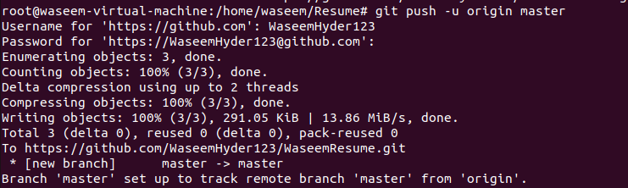

These days, Git does not accept passwords for pushing data; instead, you need to generate a token. You can do this by navigating to the settings.

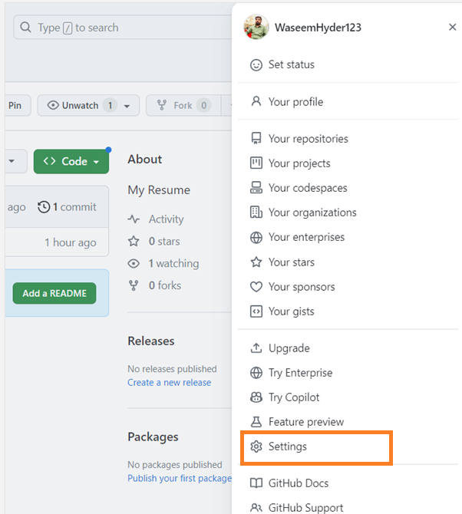

**Than developer setting.**

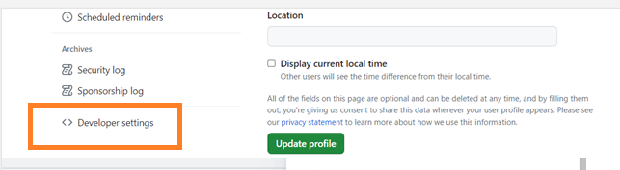

And navigate to personal access tokin

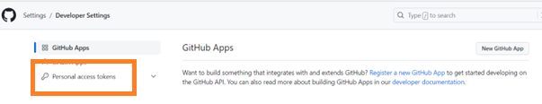

And generate tokin

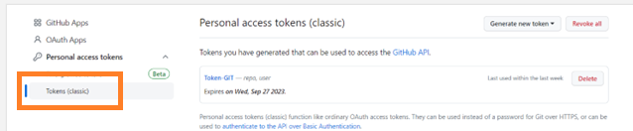

Now, our file has been successfully pushed to the central repository.

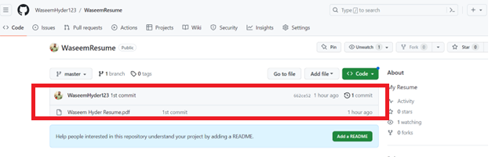

[**https://github.com/WaseemHyder123/WaseemResume.git**](https://github.com/WaseemHyder123/WaseemResume.git)

**PULL:**

Finally, to pull the file from the central repository, create a directory and initialize Git. This will allow you to fetch the latest changes from the repository.

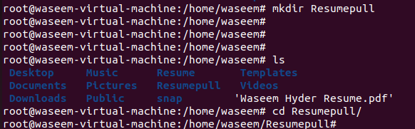

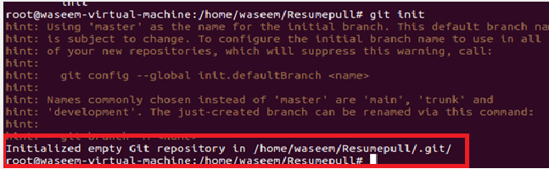

Now that the Git repository has been created after executing the git init command.

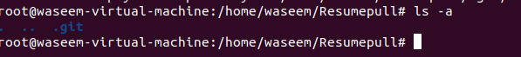

Now, you can connect to the central repository using the git remote command.



And then, you can pull the code or file from the central repository.

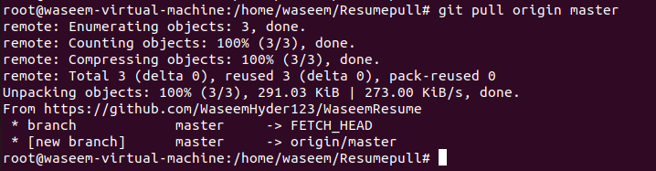

Now that the file has been successfully pulled from the repository, you can start working on it.